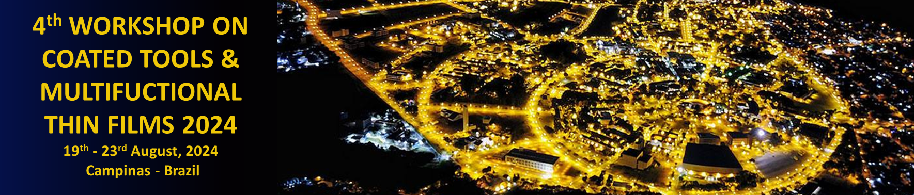

Presentation Title

A.B. Silva^{1,*}, C. Souza², D. Martins²

¹ Universidade de São Paulo, Instituto de Física de São Carlos, SP, Brazil
² Washington University, Department of Physics, St. Louis, USA
*Presenter, e-mail: aa@univ.bb

Main body: Abstracts must be written in English. You should limit the length of the abstract (main body) to no more than 2000 characters, using size 12 Times New Roman font, and left-aligned single-spaced paragraph. Please omit Figures or Tables in the abstract. The abstract should briefly state the nature and significance of the topic, the problem or purpose of the research, indicate the investigative strategy, summarize the substantive results of the work, and point out major conclusions.

Keywords: AA, BB, CC
(maximum of 5 keywords)

Acknowledgments: This work was supported by ...

References:
(maximum of 3 references)
[1] J. van der Geer, J.A.J. Hanraads, R.A. Lupton. The art of writing a scientific article, J. Sci. Commun. 163 (2010) 51–59.
[2]
[3]

